Fishery Data Series No. XX-XX
Upper Cook Inlet Personal Use Salmon Fisheries, 2004-2006
by
Kristine Dunker
and
Robert Lafferty
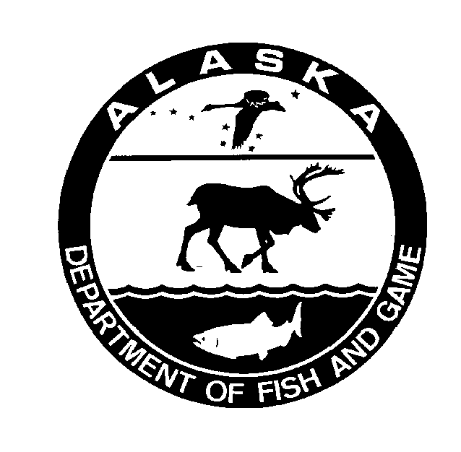
October 2007
Alaska Department of Fish and Game Divisions of Sport Fish and Commercial Fisheries
Symbols and Abbreviations
The following symbols and abbreviations, and others approved for the Système International d'Unités (SI), are used without definition in the following reports by the Divisions of Sport Fish and of Commercial Fisheries: Fishery Manuscripts, Fishery Data Series Reports, Fishery Management Reports, and Special Publications. All others, including deviations from definitions listed below, are noted in the text at first mention, as well as in the titles or footnotes of tables, and in figure or figure captions.

Weights and measures (metric)
centimeter cm
deciliter dL
gram g
hectare ha
kilogram kg
kilometer km
liter L
meter m
milliliter mL
millimeter mm

Weights and measures (English)
cubic feet per second ft³/s
foot ft
gallon gal
inch in
mile mi
nautical mile nmi
ounce oz
pound lb
quart qt
yard yd

Time and temperature
day d
degrees Celsius °C
degrees Fahrenheit °F
degrees kelvin K
hour h
minute min
second s

Physics and chemistry
all atomic symbols
alternating current AC
ampere A
calorie cal
direct current DC
hertz Hz
horsepower hp
hydrogen ion activity pH
(negative log of)
parts per million ppm
parts per thousand ppt,
‰
volts V
watts W
General
Alaska Administrative
Code AAC
all commonly accepted
abbreviations e.g., Mr., Mrs., AM, PM, etc.
all commonly accepted
professional titles e.g., Dr., Ph.D.,
R.N., etc.
at @
compass directions:
east E
north N
south S
west W
copyright ©
corporate suffixes:
Company Co.
Corporation Corp.
Incorporated Inc.
Limited Ltd.
District of Columbia D.C.
et alii (and others) et al.
et cetera (and so forth) etc.
exempli gratia
(for example) e.g.
Federal Information
Code FIC
id est (that is) i.e.
latitude or longitude lat. or long.
monetary symbols
(U.S.) $, ¢
months (tables and
figures): first three
letters Jan,...,Dec
registered trademark ®
trademark ™
United States
(adjective) U.S.
United States of
America (noun) USA
U.S.C. United States Code
U.S. state use two-letter abbreviations (e.g., AK, WA)
Measures (fisheries)
fork length FL
mideye-to-fork MEF
mideye-to-tail-fork METF
standard length SL
total length TL

Mathematics, statistics
all standard mathematical
signs, symbols and
abbreviations
alternate hypothesis H_{A}
base of natural logarithm e
catch per unit effort CPUE
coefficient of variation CV
common test statistics (F, t, χ², etc.)
confidence interval CI
correlation coefficient
(multiple) R
correlation coefficient
(simple) r
covariance cov
degree (angular ) °
degrees of freedom df
expected value E
greater than >
greater than or equal to ≥
harvest per unit effort HPUE
less than <
less than or equal to ≤
logarithm (natural) ln
logarithm (base 10) log
logarithm (specify base) log_{2,} etc.
minute (angular) '
not significant NS
null hypothesis H_{O}
percent %
probability P
probability of a type I error
(rejection of the null
hypothesis when true) α
probability of a type II error
(acceptance of the null
hypothesis when false) β
second (angular) "
standard deviation SD
standard error SE
variance
population Var
sample var

FISHERY DATA SERIES NO. XX-XX
Upper Cook Inlet personal use salmon fisheries, 2004-2006
by
Kristine J. Dunker
Division of Sport Fish, Anchorage
and

Alaska Department of Fish and Game
Division of Sport Fish, Research and Technical Services
333 Raspberry Road, Anchorage, Alaska, 99518-1599
October 2007

Robert Lafferty
Division of Sport Fish, Anchorage

The Division of Sport Fish Fishery Data Series was established in 1987 for the publication of technically oriented results for a single project or group of closely related projects. Since 2004, the Division of Commercial Fisheries has also used the Fishery Data Series. Fishery Data Series reports are intended for fishery and other technical professionals. Fishery Data Series reports are available through the Alaska State Library and on the Internet: http://www.sf.adfg.state.ak.us/statewide/divreports/html/intersearch.cfm. This publication has undergone editorial and peer review.
Kristine J. Dunker
Alaska Department of Fish and Game, Division of Sport Fish
333 Raspberry Road, Anchorage, AK 99518-1599, USA
and
Robert Lafferty
Alaska Department of Fish and Game, Division of Sport Fish
333 Raspberry Road, Anchorage, AK 99518-1599, USA

This document should be cited as:
Dunker, K.J., and R. Lafferty. 2007. Upper Cook Inlet personal use salmon fisheries, 2004-2006. Alaska Department of Fish and Game, Fishery Data Series No. XX-XX, Anchorage.
The Alaska Department of Fish and Game administers all programs and activities free from discrimination based on race, color, national origin, age, sex, religion, marital status, pregnancy, parenthood, or disability. The department administers all programs and activities in compliance with Title VI of the Civil Rights Act of 1964, Section 504 of the Rehabilitation Act of 1973, Title II of the Americans with Disabilities Act of 1990, the Age Discrimination Act of 1975, and Title IX of the Education Amendments of 1972.
If you believe you have been discriminated against in any program, activity, or facility, or if you desire further information please write to ADF&G, P.O. Box 25526, Juneau, AK 99802-5526; U.S. Fish and Wildlife Service, 4040 N. Fairfield Drive, Suite 300, Arlington, VA 22203 or O.E.O., U.S. Department of the Interior, Washington DC 20240.
For information on alternative formats for this and other department publications, please contact the department ADA Coordinator at (voice) 907-465-4120, (TDD) 907-465-3646, or (FAX) 907-465-2440.
TABLE OF CONTENTS
Page
LIST OF TABLES 1
List OF FIGURES 1
List OF APPENDICES 1
ABSTRACT 2
INTRODUCTION 2
Management Plans 2
Kasilof River 2
Kenai River 4
Fishing Regulations 4
Kasilof River Gillnet 4
Kasilof River Dip Net 4
Kenai River Dip Net 4
Objectives 5
METHODS 5
Study Design 5
Data Analysis 6
RESULTS 8
Permits Issued and Returned 8
Estimated Harvest and Effort 8
Kasilof River Gillnet 14
Kasilof River Dip Net 14
Kenai River Dip Net 13
Characteristics of Permit Holders 19
Residency of Permit Holders 19
Seasonal Variation 19
Household Size 19
Number of Days Fished/Fisheries Visited 27
DISCUSSION 27
ACKNOWLEDGEMENTS 30
references Cited 30
APPENDIX A. Examples of upper cook inlet personal use permits 31
APPENDIX B. SOCKEYE HARvesT by date during the upper cook inlet personal use fisheries, 2004-2006 35
APPENDIX c. Effort and Harvest Trends during the upper cook inlet personal use fisheries, 1996-2006 38

LIST OF TABLES
Table Page
1. Number of Upper Cook Inlet personal use salmon fishery permits issued by year and number of permits returned by mailing and year, 2004-2006. 9
2. Number of Upper Cook Inlet personal use salmon fishery permits that did not fish by year, 2004-2006. 10
3. Effort and harvest in Upper Cook Inlet personal use salmon fisheries, 2004-2006. 11
4. Flouder harvests in Upper Cook Inlet personal use fisheries, 2005-2006. 12
5. Sockeye salmon exploitation rate by Upper Cook Inlet personal use fisheries, 2004-2006. 15
6. Residence areas for Upper Cook Inlet personal use salmon fishery permit holders by year, 2004-2006. 20
7. Summary of Upper Cook Inlet personal use permit holders by year, household size, number of days fished, and number of fisheries fished, 2004-2006. 22

List OF FIGURES
Figure Page
1. Maps of the areas open to personal use fishing: Kasilof River (Panels A and B) and Kenai River
(Panel C). 3
2. Total estimated salmon harvest for all Upper Cook Inlet personal use fisheries combined.. 11
3. Cummularive harvest timing for sockeye salmon during the Kasilof River personal use gillnet fishery, 2004-2006. 15
4. Cummularive harvest timing for sockeye salmon during the Kasilof River personal use dip net fishery, 2004-2006.. 16
5. Cummularive harvest timing for sockeye salmon during the Kenai River personal use dip net fishery, 2004-2006.. 17
6. Percent of Upper Cook Inlet personal use salmon fishery permit holders from Anchorage, the Kenai Peninsula, the Matanuska-Susitna Valley and elsewhere in Region II by fishery and year. 21
7. Percent of bag limits filled by Upper Cook Inlet personal use salmon fishery permit holders, 2004-2006 22
8. Average percent of bag limit filled by fishery and year. 23
9. Percent of salmon harvested by Upper Cook Inlet personal use salmon fishery, 2004-2006. 24
10. Percent of permits, percent of total harvest and average percent of bag limit filled by fishery and household size from 2004-2006. 25
11. Percent of permits, percent of total harvest and average percent of bag limit filled by fishery and number of days fished from 2004-2006. 27

List OF APPENDICES
Appendix Page
A1. Example of a 2006 Upper Cook Inlet personal use salmon permit. 32
A2. Example of a 2005 Upper Cook Inlet personal use salmon permit. 33
B1. Sockeye harvest by date during the Kasilof River gillnet fishery, 2004-2006. 35
B2. Sockeye harvest by date during the Kasilof River dip net fishery, 2004-2006. 36
B3. Sockeye harvest by date during the Kenai River dip net fishery, 2004-2006. 37
C1. Trends in fishing effort during the Upper Cook Inlet personal use fisheries, 1996-2006. 39
C2. Trends in sockeye salmon harvest during the Upper Cook Inlet personal use fisheries, 1996-2006 40
C3. Trends in coho salmon harvest during the Upper Cook Inlet personal use fisheries, 1996-2006 41
C4. Trends in Chinook salmon harvest during the Upper Cook Inlet personal use fisheries, 1996-2006. 42
C5. Trends in chum salmon harvest during the Upper Cook Inlet personal use fisheries, 1996-2006. 43
C6. Trends in pink salmon harvest during the Upper Cook Inlet personal use fisheries, 1996-2006. 44

ABSTRACT
From 2004 to 2006 participants in the Upper Cook Inlet personal use salmon fisheries were required to record their harvest and effort on a free permit that was returned to the Alaska Department of Fish and Game after the fisheries closed. Approximately 21,900 permits were issued in 2004 and 2005, but the number of permits issued decreased to approximately 18,500 in 2006. The response rate increased from 82% to 89% during the same period. Returned permits were used to estimate harvest and effort for the Kasilof River gillnet, Kasilof River dip net and Kenai River dip net fisheries. Sockeye salmon harvest from 2004 to 2006 averaged 26,964 for the Kasilof River gillnet fishery, 49,203 for the Kasilof River dip net fishery, and 228,652 for the Kenai River dip net fishery. Most permits were issued to residents of Anchorage followed by residents of the Kenai Peninsula and the Matanuska-Susitna Valley. Most permit holders did not fill their seasonal bag limit and differences in the percentage of the bag limit filled varied most with respect to year and the amount of effort spent fishing.
Key words: Kenai River, Kasilof River, Fish Creek, personal use, dip net, gillnet, subsistence, sockeye salmon, coho salmon, Chinook salmon, pink salmon, chum salmon, flounder, permit.

INTRODUCTION
Subsistence and personal use (PU) fishing in Cook Inlet has undergone numerous regulatory changes over the past two decades, reflecting the efforts by the state and federal governments and the court system to develop a legal definition of subsistence use (Brannian and Fox 1996). In 1996, most of Cook Inlet was closed to subsistence harvest of salmon. In lieu of subsistence fisheries four personal use fisheries were opened to all Alaska residents: Fish Creek dip net, Kasilof River gillnet, Kasilof River dip net, and Kenai River dip net (Figure 1). All of these fisheries target sockeye salmon Oncorhynchus nerka, although Chinook salmon O. tshawytscha, coho salmon O. kisutch, pink salmon O. gorbuscha, chum salmon O. keta, and flounder Pleuronectidae are harvested incidentally. All participants in the Upper Cook Inlet personal use (UCIPU) fisheries are required to get a free permit or be a member of a household with a permit. UCPIU permits are household permits that allow all members of the household to fish under the same permit. Completed permits must be returned to the Department following each fishing season. The dip net fishery in Fish Creek was closed during the entire study period because of poor in-river returns. This report presents harvest, effort and other summary information from UCIPU salmon permits issued during the 2004-2006 seasons for the Kenai and Kasilof fisheries.

Management Plans
All UCIPU salmon fisheries are managed under the provisions of the Upper Cook Inlet Personal Use Salmon Fishery Management Plan (5 AAC 77.540).

Kasilof River
In-season management of the gillnet fishery is the responsibility of the Commercial Fisheries Division (CFD). CFD also operates a sonar counter on the Kasilof River. From 1996-2001 the gillnet fishery was opened and closed by emergency order based on a target harvest range. In 2002, the BOF changed the management plan so that the gillnet fishery opens and closes by regulation, therefore in-season management is required only if the sonar count and biological escapement goal cannot be projected. In-season management of the dip net fishery is the responsibility of the sport fish division (SFD). The dip net fishery also opens and closes by regulation, and in-season management is only required if the sonar count and biological escapement goal cannot be projected.

Panel A
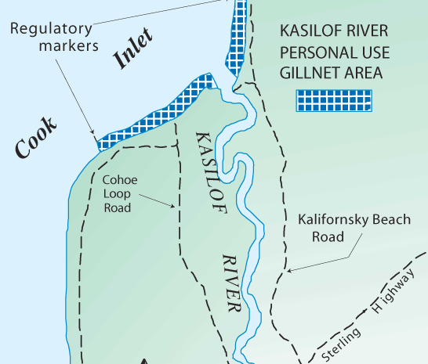
Panel B
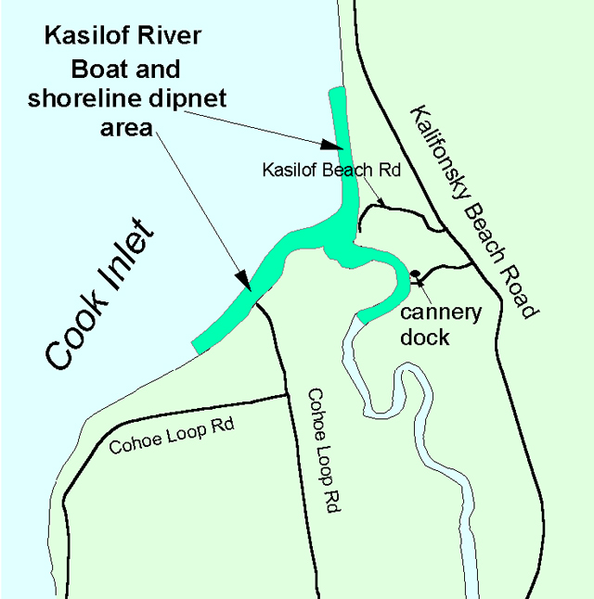
Panel C
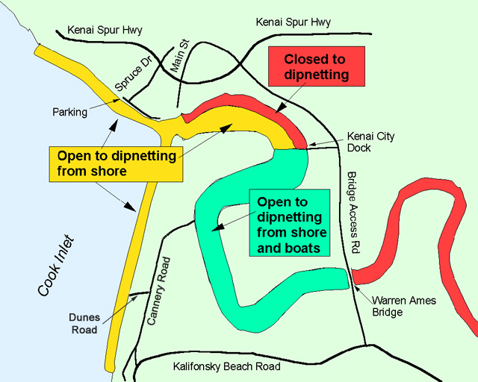

Figure 1.-Maps of the areas open to personal use fishing: Kasilof River (Panels A and B) and Kenai River (Panel C).

Kenai River
In-season management of this fishery is the responsibility of SFD. The fishery opens and closes by regulation, and in-season management by SFD is only required if it is projected that the in-river escapement goal for sockeye salmon will not be met.

Fishing Regulations
Regulations for these fisheries are outlined in 5 AAC 77.015, 5 AAC 77.525 and 5 AAC 77.540. The fisheries are open to Alaskan residents only. A legal dip net is a bag-shaped net supported on all sides by a rigid frame. The net opening may not exceed 5-ft. across, and the depth of the net must be at least one-half the net opening. The mesh used to construct the net may not exceed 4.5 inches stretched. Dip nets must be operated by hand. The total annual limit for all UCIPU fisheries was 25 salmon for the head of the household and 10 salmon for each additional household member. There was an annual limit of one Chinook salmon from the Kenai River dip net fishery, and no Chinook salmon could be retained from the Kasilof River dip net fishery. However, there was no annual limit for Chinook salmon caught in the Kasilof River gillnet fishery.

Kasilof River Gillnet
The legal fishing area was from ADF&G regulatory markers located at the river mouth to ADF&G commercial fishing regulatory markers located approximately one mile from the mouth in either direction (Figure 1; Panel A). Additionally, fishing was prohibited more than one mile from the mean high tide mark and within any flowing waters of the Kasilof River at any tide stage. Only one set gillnet could be operated per permit. The gillnet had to be attended, by the permit holder or a person named on the permit, at all times it was being used to harvest fish. No set gillnet could be operated within 100 feet of another set gillnet. The gillnet could not exceed 10 fathoms in length, have larger than a six-inch mesh size, or be more than 45 meshes deep. By regulation, the fishery was open from June 15 through June 24, from 0600 to 2300.

Kasilof River Dip Net
Dip netting was allowed in the area from regulatory markers located on the Cook Inlet beaches outside of the terminus of the river upstream for one mile (Figure 1; Panel B). The dip-netting season began on June 25 and ended on August 7. During this season, dip netting was open 24 hours a day.

Kenai River Dip Net
Dip nets could only be used from shore in the area from ADF&G regulatory markers located on the Cook Inlet beaches outside of the terminus of the river upstream to the Warren Ames Bridge (Figure 1, Panel C). The north shoreline was closed to dip netting from shore between an ADF&G marker located below Main Street in Kenai upstream to the Kenai City Dock. This regulation was implemented to minimize erosion to the bluffs below the city of Kenai.
Dipnetting from a boat was only allowed from ADF&G markers located near the Kenai City Dock upstream to the Warren Ames Bridge. The fishery was open from July 10 through July 31, from 0600 to 2300.

Objectives
From 2004-2006 the objectives of the study were to:
- Make permits available to Alaskan residents that qualified to participate in upper Cook Inlet personal use fisheries;
- Estimate participation (household days fished) and harvest for the Kasilof River gillnet, Kasilof River dip net, and Kenai River dip net fisheries such that the estimates were within 10% of true values 95% of the time.

METHODS

Study Design
All participants in the UCIPU salmon fisheries were required to get a permit or be a member of a household with a permit. Permits were free to residents with valid Alaska sport fishing licenses and were issued by more than 60 vendors and ADF&G offices located in Anchorage, Fairbanks, the Kenai Peninsula and the Matanuska-Susitna Valley.
Each permit was divided into numbered halves (Appendix A1). Permits were sequentially numbered, and vendors were given known sequences. The top half was a vendor copy which was retained by the vendor and contained the permit holder’s contact information, sport fishing license number and the angler’s signature. Vendor copies were returned to the Anchorage ADF&G office periodically throughout the summer using courtesy reply envelopes provided by the Division of Sport Fish. Data from the returned vendor copies were entered into an electronic database periodically throughout the summer.
The bottom half of each permit was a harvest card that was given to the permit holder. The permit holder was required to have this permit in their possession when personal use fishing. Permit holders were also required to record harvest information including fishery, dates fished and salmon harvest by species immediately upon harvesting a fish. A check box was provided for households that did not fish. All permits, even for households that did not fish, were required to be returned to ADF&G by August 15.
Permit holders who did not return their permits received up to two reminder letters. Reminder letters were mailed to allow an approximately four-week response period for the previous mailing. Data from returned permits were entered into an electronic database as they were received. In some cases returned permits reported that the household harvested in excess of their seasonal bag limit, fished out of season, were not Alaskan residents, or some other regulatory violation. This information was entered into the database as it was recorded on the permit.
All permit-holders who returned their permits before the second reminder letter were considered “compliant” households. Information obtained by permit-holders who returned their permits after the second reminder letter was mailed were considered “non-compliant” households. Participation and harvest by non-compliant households was estimated by calculating the mean participation (household days fished) and harvest by species for non-compliant permits that were returned. These were then expanded to include all non-respondents. Total estimates of participation and harvest by species for each fishery were obtained by summing the estimates for the non-compliant households with the information obtained from compliant households.
Occasionally vendors failed to return vendor copies from some of the permits they issued. This resulted in some permit holders returning permits that lacked a vendor copy. The total number of permits issued was estimated by assuming that the response rate (prior to mailing the first reminder letter) among known permits from a vendor was the same as the response rate among the permits lacking a vendor copy (the “orphan permits”). This response rate was applied to the orphan permits to estimate the total number of permits issued by the vendor but missing vendor copies.
In 2005, the permit was designed such that permit holders were to circle the fishery they participated in (Appendix A2). Many permit holders did not fill this out correctly which resulted in a large number of reported harvests for which the correct dip net fisheries were unknown during the dates that the Kenai and Kasilof dip net fisheries overlap (July 10th – 31st). To correct this, a telephone survey was conducted of 150 permit holders with “unknown” data. The proportion of permit holders who fished the Kenai (89%) versus the Kasilof (11%) was the same between the phone survey sample and the known permit holders. This proportion was used to correct the unknown data in 2005.

Data Analysis
Because some vendors did not return all of their permits, the total number of permits issued was estimated as:
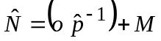 | (1)
where:
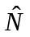 = | the total number of permits issued,
= | the number of permits issued and returned by permit holders before the first reminder letter, but with no vendor card (the “orphan permits”),
 = | 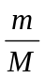= | the response rate before the first reminder letter among permits with vendor cards,
= | the number of permits returned before the first reminder letter mailing with vendor cards,
 = | the total number of permits with vendor cards.
With variance estimated as:
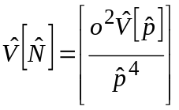 , | (2)
where,
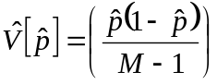 .
The estimated number of permits issued was divided in four groups:
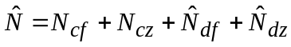 , | (3)
where:
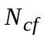= | the number of compliant permits who reported fishing,
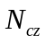= | the number of compliant permits who reported they did not fish,
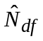= | 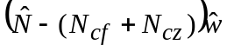,
 | the estimated number of non-compliant permits who reported fishing, and,
 | where 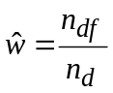
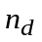 = the number of non-compliant households responding to the last reminder, and,
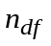 = the number of non-compliant households who responded to the last reminder and reported fishing.
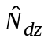= | the estimated number of non-compliant permits who reported they did not fish.

Harvest for each species or participation for each fishery was estimated by the following procedure (with subscripts denoting parameter of estimation deleted for simplicity):
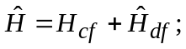 | (4)
where:
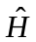 = | estimated total harvest or participation;
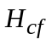 = | harvest or participation reported by compliant permits, and;
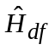 = | estimated harvest by non-compliant households = 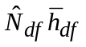
where 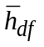 = the mean harvest or participation per household for non-compliant households that fished.
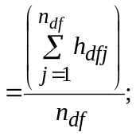
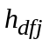 = | reported harvest by responding non-compliant household j, and
= | the number of non-compliant households responding to the reminder mailings.
Variance was calculated as (Goodman 1960):
, | (5)
where:
, | (6)
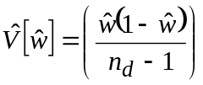,
and
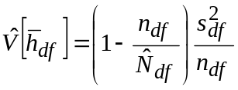 , | (7)
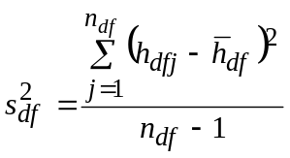 . | (8)
Standard errors were the square root of the variance estimates. Permit holders who failed to indicate which fishery they participated in were estimated as “unknown fishery” by the procedure outlined above.
The number of permits issued was estimated for each vendor following formulas one and two and then summed across vendors to get an estimate of the total number of permits issued. The non-compliant permits were not divided into those that reported not fishing and those that fished. Formulas 3-8 were used to estimate harvest and participation ignoring the second subscript.

RESULTS

Permits Issued and Returned
The numbers of permits issued for UCIPU fisheries were similar during the first two years of this study with an estimated 21,900 (SE = 2) permits issued in 2004 and 21,905 (SE =1) permits issued in 2005 (Table 1). In 2006, the number of permits issued decreased to an estimated 18,563 (SE = 1). The percent of permits returned increased from 82% in 2004 to 89% in 2006. On average, 61% of permit holders returned their permits voluntarily, 19% were returned after the first reminder letter, and 8% were returned after the second reminder. Approximately 21% of the households that were issued UCIPU permits did not fish (Table 2).

Estimated Harvest and Effort
Approximately 970,000 salmon were harvested in the UCIPU salmon fisheries between 2004 and 2006. Total harvest was greatest in 2005 (377,271 salmon, SE=314) and lowest in 2006 (234,391 salmon, SE = 242; Table 3). All five species of salmon were harvested with sockeye comprising the majority (Figure 2). Effort for all fisheries averaged 24,385 household days. As with the harvest, fishing effort was greatest in 2005 (27,253 days fished, SE = 21), but lowest in 2006 (20,543 days fished, SE = 20; Table 3). The Kenai River dip net fishery was the most popular of the UCIPU fisheries, and most of the salmon harvest and effort occurred there (Table 3). Beginning in 2005, participants in the personal use fisheries were allowed to harvest flounder, and the greatest harvest of flounder occurred in the Kenai dip net fishery (Table 4).
Table 1.–Number of UCIPU salmon fishery permits issued by year and number of permits returned by mailing and year, 2004-2006.
 |  | Permits Issuedª |  |  | Permits Returned^{b} |  |  |  |  |  |  |  |  |  |  |  |  | Permits not Returned
 |  |  |  |  | Voluntary |  |  | Mailing 1 |  |  | Mailing 2 |  |  |  | Total
Year |  | Number | SE |  | Number | % |  | Number | % |  | Number | % |  |  | Number | % |  | Number | %
2004 |  | 21,910 | 2 |  | 10,653 | 49% |  | 2,075 | 10% |  | 5,020 | 23% |  |  | 17,748 | 82% |  | 3,868 | 18%
2005 |  | 21,905 | 1 |  | 12,760 | 59% |  | 4,150 | 19% |  | 2,171 | 10% |  |  | 19,081 | 88% |  | 2,680 | 12%
2006 |  | 18,563 | 1 |  | 11,658 | 63% |  | 3,632 | 20% |  | 1,242 | 7% |  |  | 16,532 | 89% |  | 1,996 | 11%
Mean |  | 20,234 |  |  | 12,209 | 61% |  | 3,891 | 19% |  | 1,707 | 8% |  |  | 17,807 | 88% |  | 2,338 | 12%
a-"Permits Issued" is an estimate that accounts for "orphan permits".
b- "Permits Returned" and 'Permits not Returned" are based on permits actually received and are not estimates.
c- Voluntary households are those that voluntarily returned their completed permits without being mailed a reminder letter.
d- The hiatus between courtesy reminders was not strictly followed by the mailing service in 2004.

Table 2.–Number of UCIPU salmon fishery permits that did not fish by year, 2004-2006.
 |  | Permits issued |  |  | Did not fish
Year |  | Number | SE |  | Number | %
2004 |  | 21,910 | 2 |  | 4,001 | 19%
2005 |  | 21,905 | 1 |  | 3,840 | 18%
2006 |  | 18,563 | 1 |  | 4,695 | 25%
Mean |  | 20,793 |  |  | 4,179 | 21%

Table 3.–Effort and harvest in the UCIPU salmon fisheries, 2004-2006.
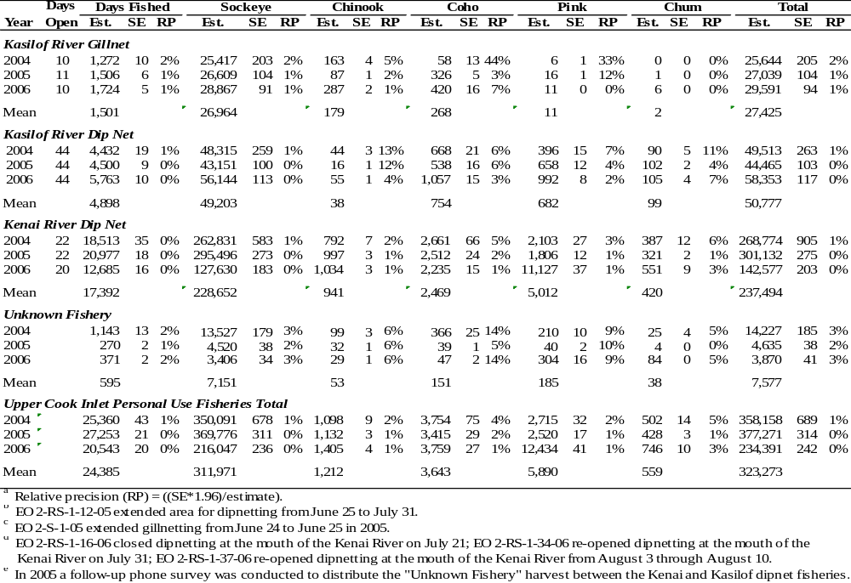

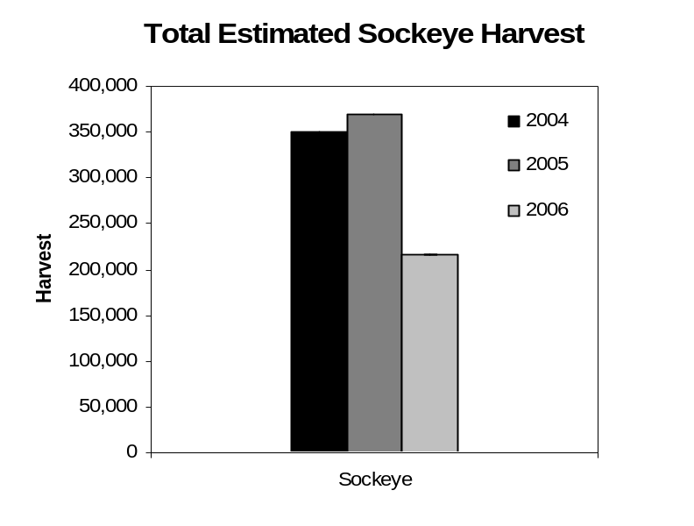
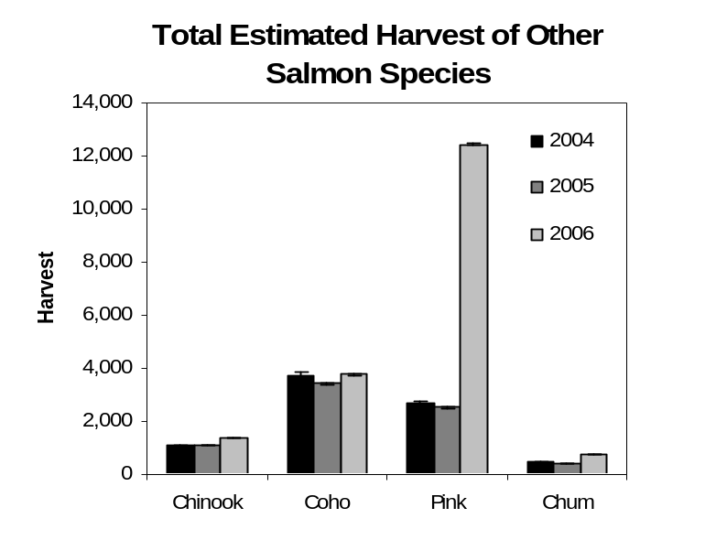
Figure 2.-Total estimated salmon harvest for all UCIPU fisheries combined. The top figure shows harvest of sockeye salmon, and the bottom figure shows harvest for all other salmon species. Note the difference in y-axis scale.
Table 4.–Flounder harvests in UCIPU fisheries, 2005-2006.
 |  | Days Open | Days Fished |  |  |  | Flounder
Year |  | Days Open | Est. | SE | RPª |  | Est. | SE | RPª
Kasilof Gill Net
2005^{c} |  | 11 | 1,506 | 6 | 1% |  | 101 | 1 | 2%
2006 |  | 10 | 1,724 | 5 | 1% |  | 162 | 2 | 2%
Kasilof Dip Net
2005^{b} |  | 44 | 4,500 | 9 | <1% |  | 322 | 3 | 2%
2006 |  | 44 | 5,763 | 10 | <1% |  | 215 | 2 | 2%
Kenai River Dip Net
2005 |  | 22 | 20,977 | 18 | <1% |  | 1,572 | 5 | 1%
2006^{d} |  | 20 | 12,685 | 16 | <1% |  | 1,913 | 11 | 1%
Unknown Fishery
2005 |  |  | 270 | 2 | 1% |  | 29 | 2 | 14%
2006 |  |  | 371 | 2 | 2% |  | 45 | 3 | 13%
Upper Cook Inlet Personal Use Fisheries Total
2005 |  |  | 27,253 | 21 | <1% |  | 2,024 | 6 | 1%
2006 |  |  | 20,543 | 20 | <1% |  | 2,335 | 12 | 1%
ª Relative precision ((SE*1.96)/estimate)
^{b} EO 2-RS-1-12-05 extended area for dip netting from June 25 to July 31.
^{c} EO 2-S-1-05 extended gillnetting from June 24 to June 25 in 2005.
^{d} EO 2-RS-1-16-06 closed dipnetting at the mouth of the Kenai River on July 21; EO 2-RS-1-34-06
re-opened dipnetting at the mouth of the Kenai River on July 31; EO 2-RS-1-37-06 re-opened
dipnetting at the mouth of the Kenai River from August 3 through August 10.

Kasilof River Gillnet
During this study, participation in the Kasilof River gillnet fishery averaged 1,501 household days with a range of 1,272 (SE = 10) household days in 2004 to 1,724 (SE = 5) household days in 2006 (Table 3). Sockeye salmon harvest during the same period averaged 26,964 fish and ranged from 25,417 (SE = 203) fish in 2004 to 28,867 (SE = 91) fish in 2006 (Table 3). Chinook salmon harvests averaged 179 fish but ranged from 87 (SE = 1) fish in 2005 to 287 (SE = 2) fish in 2006 (Table 3). The relative precision goals (±10% of the true value 95% of the time) for effort and harvest of sockeye and Chinook salmon were met each year.
Sockeye salmon harvest in the Kasilof River personal use gillnet fishery resulted in exploitation rates ranging from 3.9% of the in-river return in 2004 to 6.3% of the in-river returns in 2005 and 2006 (Table 5). The Kasilof River gillnet fishery has the shortest season of the UCIPU fisheries. Over 50% of the sockeye were harvested by June 19 and 20 which are the median dates for this fishery (Figure 3; Appendix B1).
Kasilof River Dip Net
Between 2004 and 2006, participation in the Kasilof River dip net fishery averaged 4,898 household days with a range of 4,432 (SE = 19) days in 2004 to 5,763 (SE = 38) days in 2006 (Table 3). Sockeye harvest during this period averaged 49,203 fish with the greatest harvest occurring in 2006 (56,144 sockeye salmon, SE = 113). Harvests of other species were relatively small. The relative precision goals (± 10% of the true value 95% of the time) for fishing effort and sockeye harvest were met each year.
Exploitation rates for sockeye harvest in the Kasilof River personal use dip net fishery ranged from 7.3% of the in-river return in 2004 to 12.2% in 2006 (Table 5). When combined with the exploitation rate for the Kasilof gillnet fishery, the total sockeye exploitation rate from personal use fisheries in the Kasilof River averaged 15.4% (Table 5). The harvest timing of the Kasilof River dip net fishery was relatively consistent between years. Over half the sockeye harvested were taken by July 15th in 2004 and 2005 and by July 18th in 2006 (Figure 4; Appendix B2).

Kenai River Dip Net
Participation in the Kenai River dip net fishery averaged 17,392 household days and ranged from 12,685 (SE = 16) household days in 2006 to 20,977 (SE = 18) days in 2005 (Table 3). Sockeye salmon harvest averaged 228,652 fish with a range of 127,630 (SE = 183) fish in 2006 to 295,496 (SE = 273) fish in 2005 (Table 3). Harvests of other species were comparatively small. The relative precision goals (±10% of the true value 95% of the time) for effort and harvest of all salmon species were met each year.
Sockeye harvest in the Kenai River dip net fishery resulted in exploitation rates ranging from 7.7% (2006) to 17.1% (2005) of the in-river return (Table 5). The mean exploitation rate was 13.5%, the same as in previous years (Reimer and Sigurdsson 2004). The in-season closings and re-openings of the Kenai River dip net fishery in 2006 likely resulted in the lower participation, harvest and exploitation rates observed that year (Tables 3 and 5). The median date for Kenai River personal use sockeye harvest was July 20th, approximately half way through the typical open season (Figure 5). In 2006, most sockeye were harvested before the in-season closure. Approximately 20% of the sockeye were taken when the fishery re-opened on July 31st and August 3rd-10th (Appendix B3).
Table 5. Sockeye salmon exploitation rate by UCIPU salmon fishery, 2004-2006.
 |  | Harvest |  |  | In-river |  |  | Exploitation Rate
Year |  | Dip net | Gillnet |  | Return | ª |  | Dip net | Gillnet | Combined
Kasilof River
2004 |  | 48,315 | 25,417 |  | 658,686 |  |  | 7.3% | 3.9% | 11.2%
2005 |  | 43,151 | 26,609 |  | 423,825 |  |  | 10.2% | 6.3% | 16.5%
2006 |  | 56,144 | 28,867 |  | 460,769 |  |  | 12.2% | 6.3% | 18.4%
Mean |  | 49,203 | 26,964 |  | 514,427 |  |  | 9.9% | 5.5% | 15.4%
Kenai River
2004 |  | 262,831 |  |  | 1,663,956 |  |  | 15.8%
2005 |  | 295,496 |  |  | 1,731,733 |  |  | 17.1%
2006 |  | 127,630 |  |  | 1,650,351 |  |  | 7.7%
Mean |  | 228,652 |  |  | 1,682,013 |  |  | 13.5%
a- In-river return calculated as total run estimate minus commercial harvest; from Tobias and Willette
(in prep).

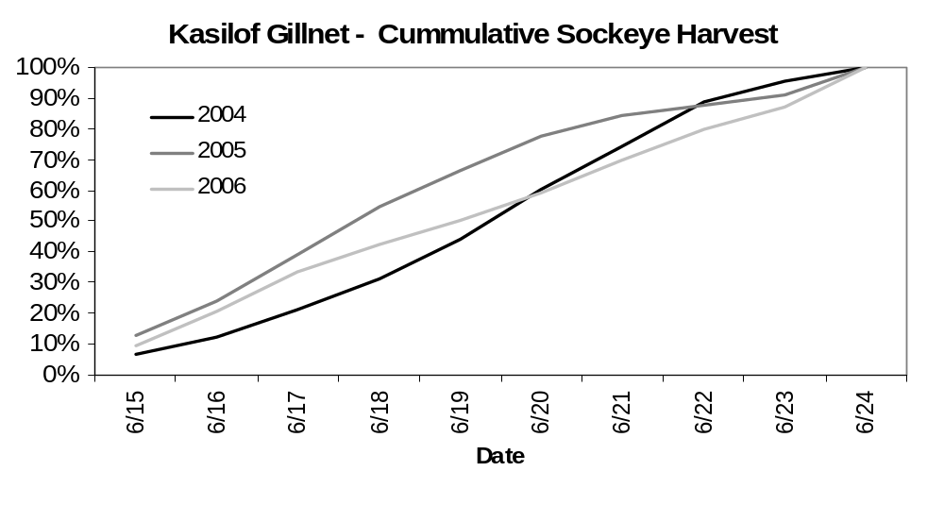
ª Total harvest of sockeye salmon by day is listed in Appendix B1.

Figure 3. Cumulative harvest timing for sockeye salmon during the Kasilof River personal use gillnet fishery 2004-2006.

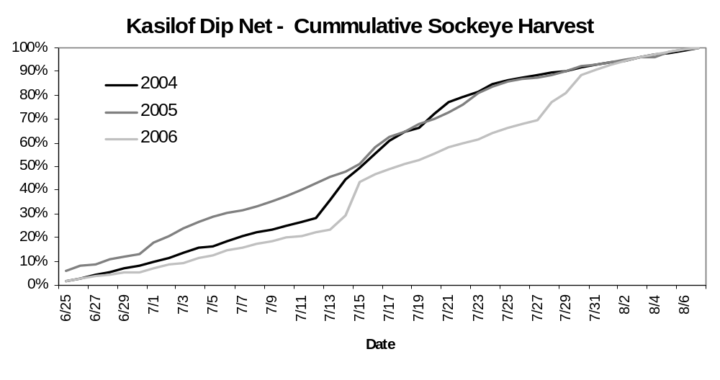
ª Total harvest of sockeye salmon by day is listed in Table B2.

Figure 4. Cumulative harvest timing for the Kasilof River personal use dip net fishery 2004-2006.

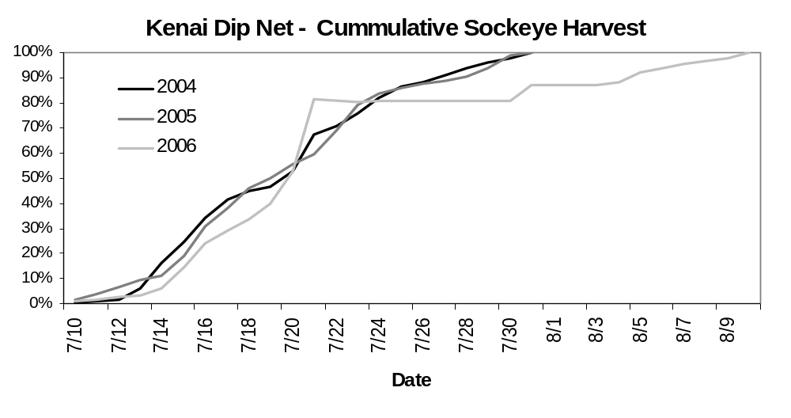
ª Total harvest of sockeye salmon by day is listed in Table B3.

Figure 5. Cumulative harvest timing for sockeye salmon during the Kenai River personal use dip net fishery 2004-2006.
Characteristics of Permit Holders

Residency of Permit Holders
Approximately 97% of all UCIPU permit holders resided in Southcentral Alaska (Region II) during each year of the study (Table 6). Less than three percent of the participants lived in the Interior, and less than one percent resided in Southeast. Of the participants from Southcentral, the majority were from Anchorage, followed by the Kenai Peninsula, and the Matanuska-Susitna Valley. The percentage of permit holders from Anchorage was relatively consistent throughout the study, but there has been an increasing trend in the percentage of participants from Anchorage in the UCIPU fisheries over the last ten years (Reimer and Sigurdsson 2004).
Anchorage residents were a substantial majority of the participants in the Kenai River and Kasilof River personal use dip net fisheries (Figure 6). They also comprised the majority of permit holders who did not participate in any of the UCIPU fisheries. Residents of the Kenai Peninsula were the predominate participants in the Kasilof River personal use gillnet fishery in 2004, but participation in this fishery by Kenai Peninsula residents did not differ much from Anchorage residents in 2005 and 2006. Participation in the Kasilof gillnet fishery by residents of the Matanuska-Susitna valley increased during the study period (Figure 6). Overall, patterns in the residency of participants in the UCIPU fisheries were relatively consistent from 2004 to 2006.

Seasonal Variation
Participants in the UCIPU fisheries were more efficient in 2004 and 2005 than they were in 2006. The average percentage of the bag limits harvested by all Upper Cook Inlet permit holders dropped from approximately 39% in 2004 and 2005 to approximately 29% in 2006 (Table 7). Over 25% of permit holders did not harvest any of their allowable bag limits during each year of the study, and less than 20% of permit holders harvested the majority of their bag limits (81-100%; Figure 7). The Kasilof River gill net fishery is the least utilized of all the UCIPU fisheries (Table 3). However, on average, those participants fishing the Kasilof River gillnet fishery were the most successful and filled over 70% of their bag limits whereas participants fishing the dip net fisheries harvested less than half of what they were allowed (Figure 8).
Of all of the salmon harvested in UCIPU fisheries, over 60% came from the Kenai River dip net fishery each year whereas less than 30% were typically harvested from the Kasilof River fisheries (Figure 9). However, in comparison to the first two years of the study, the percentage of salmon harvested from the Kasilof River fisheries nearly doubled in 2006, when there were in-season closures to the Kenai dip net fishery.

Household Size
Permits were most commonly issued to two-person households from 2004 to2006 (Table 7). While some very large households did obtain permits, households of five people or less obtained 92.9% of the total permits issued during this period (Table 6). For all permits issued, the average percentage of the bag limit harvested did not vary substantially for households of different sizes (Table 6). Likewise, when data were analyzed separately by fishery using data from permit holders who actually fished and participated in only one fishery, there was, again, little variation in the average percentage of the bag limit filled (Figure 10). Overall patterns in the percentage of permits and the percentage of salmon harvested according to household size were remarkably similar between fisheries (Figure 10).
Table 6. Residence areas for UCIPU salmon fishery permit holders by year, 2004-2006.
 | SWHS |  | Year
Area of Residence | Areaª |  | 2004 | 2005 | 2006
Regional breakdown^{b}
Region 1 | A-H |  | 0.1% | 0.2% | 0.2%
Region 2 | J-N,P-T |  | 97.1% | 97.0% | 96.7%
Region 3 | I, U-Z |  | 2.5% | 2.7% | 2.9%
Out of State/Unknown residence |  |  | 0.3% | 0.2% | 0.2%
SUM |  |  | 100% | 100% | 100%
Region 2 breakdown
Anchorage area | L |  | 61.1% | 61.0% | 59.8%
Kenai Penninsula area | P |  | 25.0% | 24.5% | 26.1%
Matanuska-Susitna Valley area | K |  | 12.1% | 12.9% | 12.6%
Other region 2 areas | J,M,N,Q-T |  | 1.8% | 1.6% | 1.5%
SUM |  |  | 100% | 100.0% | 100.0%
ª Statistical areas used in the Statewide Harvest Survey (Jennings et al. 2006).
^{b} Region 1 is Southeastern Alaska, Region 2 is Southcentral Alaska, and Region 3 is Interior Alaska.

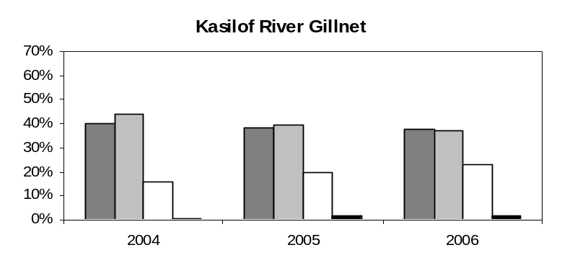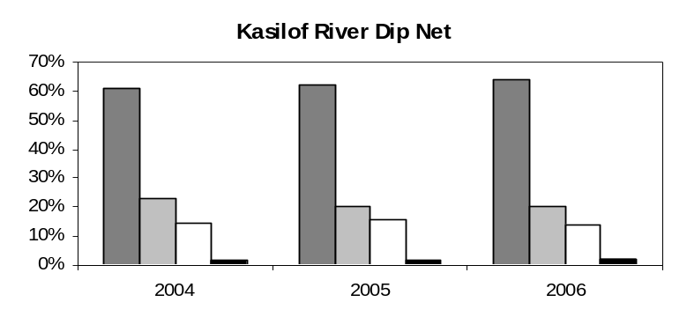
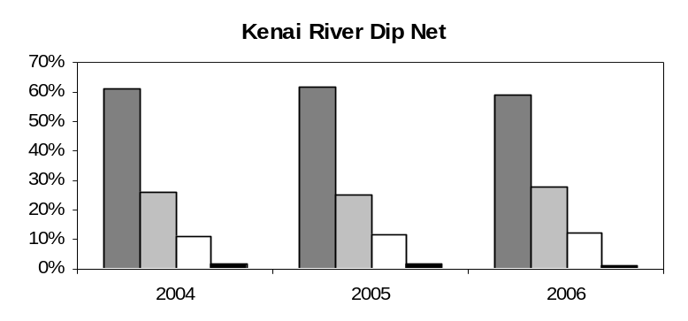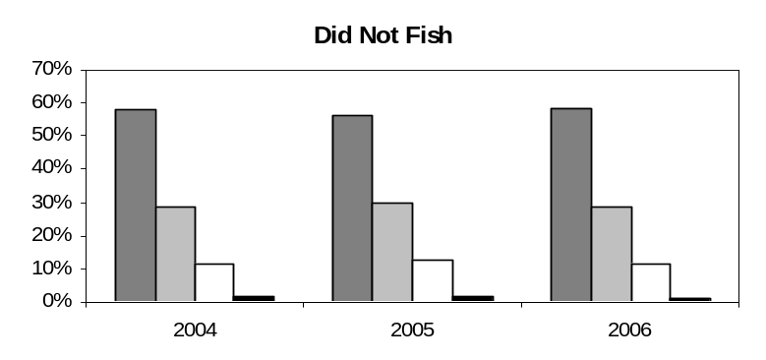

- Anchorage
- Kenai Peninsula
- Matanuska-Susitna Valley
- Other

Figure 6.-Percent of UCIPU salmon fishery permit holders from Anchorage, the Kenai Peninsula, the Matanuska-Susitna Valley and elsewhere in Region II by fishery and year.

Table 7.–Summary of UCIPU permit holders by year, household size, number of days fished, and number of fisheries fished, 2004-2006.

 | % of permits |  | % of total harvest |  | Average % of bag limit filled | SE (% of bag limit filled)
Year
2004 | 35.1% |  | 36.9% |  | 38.6% | 0.3%
2005 | 35.1% |  | 38.9% |  | 39.7% | 0.3%
2006 | 29.8% |  | 24.2% |  | 29.6% | 0.3%
Total | 100.0% |  | 100.0%
Number of household members ª
1 | 15.3% |  | 8.8% |  | 37.0% | 0.4%
2 | 33.1% |  | 27.6% |  | 38.5% | 0.3%
3 | 16.5% |  | 16.0% |  | 34.8% | 0.4%
4 | 18.7% |  | 21.6% |  | 34.2% | 0.3%
5 | 9.3% |  | 12.6% |  | 33.6% | 0.5%
6 | 3.9% |  | 6.4% |  | 35.0% | 0.7%
7+ | 3.2% |  | 7.0% |  | 37.1% | 0.8%
Total | 100.0% |  | 100.0%
Number of days ª
0 | 25.8% |  | 0.0% |  | 0.0% | 0.0%
1 | 43.8% |  | 46.4% |  | 33.2% | 0.2%
2 | 19.2% |  | 30.2% |  | 48.7% | 0.3%
3 | 7.1% |  | 13.6% |  | 65.5% | 0.5%
4 | 2.6% |  | 5.9% |  | 72.8% | 0.7%
5+ | 1.5% |  | 3.9% |  | 78.2% | 0.9%
Total | 100.0% |  | 100.0%
Number of fisheries fished ª
0 | 25.8% |  | 0.0% |  | 0.0% | 0.0%
1 | 68.1% |  | 89.2% |  | 75.5% | 0.2%
2 | 5.7% |  | 10.4% |  | 65.9% | 0.6%
3 | 0.4% |  | 0.4% |  | 71.9% | 1.8%
Total | 100.0% |  | 100.0%

ª For all permits and years combined

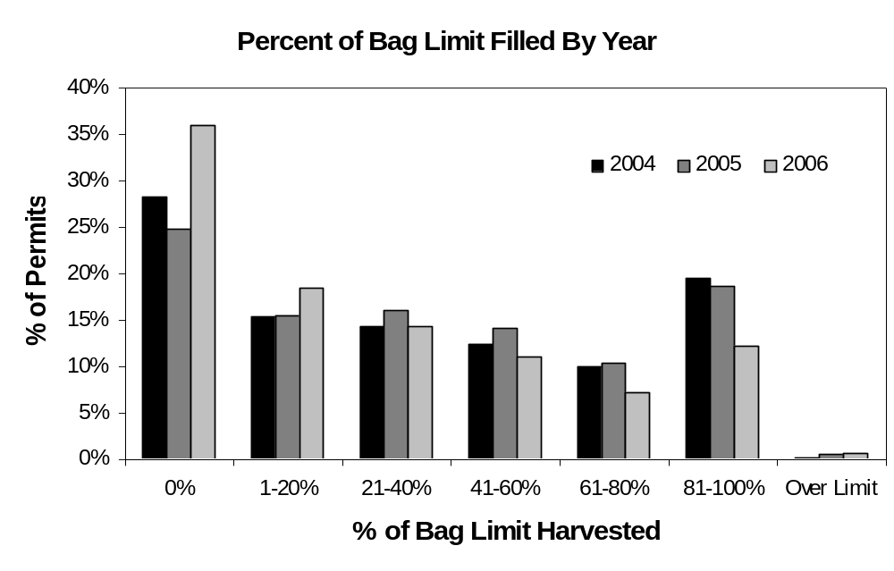
Figure 7.-Percent of bag limits filled by UCIPU salmon fishery permit holders, 2004 - 2006.

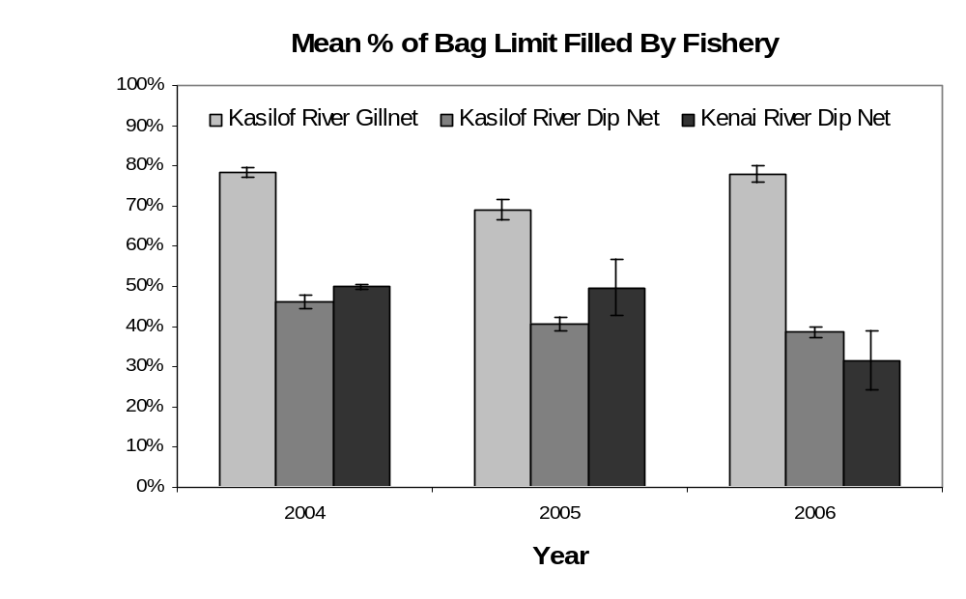
% of Bag Limit
ª Data presented are for permit holders that only participated in one fishery (92% of permit holders who fished).
^{b.} Error bars represent 95% confidence intervals.

Figure 8.–Average percent of bag limit filled by fishery and year.
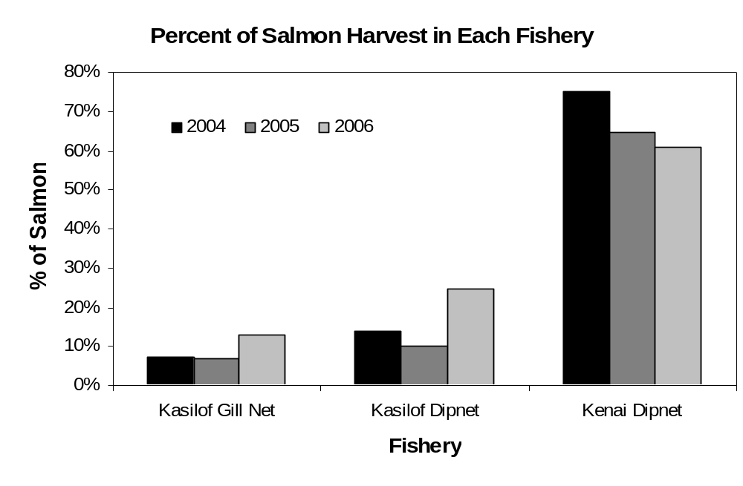
ª Data presented exclude salmon reported from permits with "unknown" fisheries (8.9%).

Figure 9.-Percent of salmon harvested by UCIPU salmon fishery, 2004 - 2006.

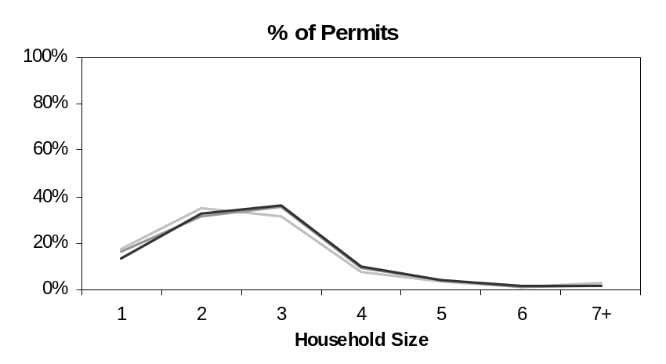
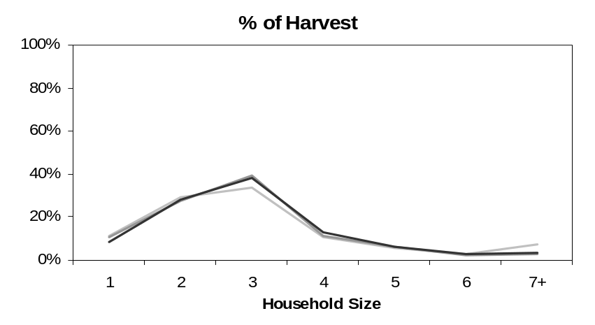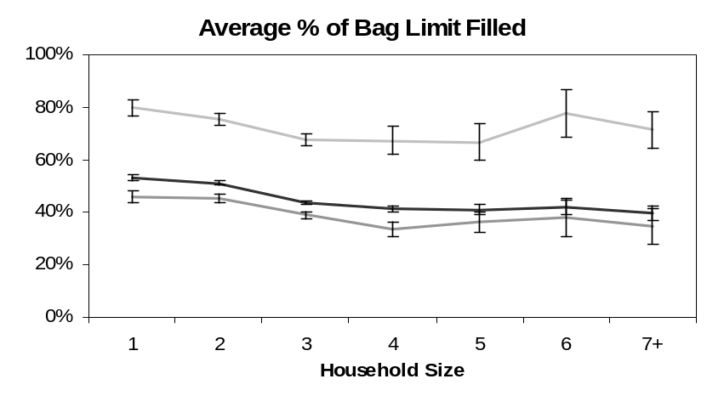
ª Data presented are for permit holders that only participated in one fishery (92% of permit holders who fished).

Kasilof River Gillnet
Kasilof River Dip Net
Kenai River Dip Net
^{b.} Error bars represent 95% confidence intervals.

Figure 10.–Percent of permits, percent of total harvest and average percent of bag limit filled by fishery and household size from 2004-2006.

Number of Days Fished/Fisheries Visited
Many permit holders fished multiple days per season although 43.8% of permit holders fished only one day (Table 7). Those permit holders who did fish more than one day increased their success from 33.2% (SE=0.2%) of their bag limit for households that fished one day to 78.2% (SE=0.9%) for households that fished five or more days. When data were analyzed separately by fishery for those permit holders that participated in only one fishery, the average percentage of the bag limit filled increased as the effort (days fished) increased for all UCIPU fisheries (Figure 11). People fishing the Kasilof gill net fishery for five or more days were the most successful in filling their bag limits. Though dip netters, in general, increased their success with added days of fishing effort, there was little variation in the average percentage of the bag limits filled between the Kenai and Kasilof dipnet fisheries. Overall, the patterns in the percentage of permits, the percentage of salmon harvested, and the average percent of the bag limits filled over multiple days were, again, quite similar between all the UCIPU fisheries (Figure 11).
Few UCIPU permit holders participated in more than one fishery from 2004 to 2006 (Table 7). Of those who participated in two fisheries, 90% fished the Kenai River along with another fishery (most often Kasilof River dip net). Of those who participated in three fisheries, combinations involving the Kenai River accounted for 98.7%. During this study period, fishing in more than one fishery did not appear to have a large effect on the average percentage of the bag limit filled (Table 7).

DISCUSSION
More UCIPU permits were issued during this study than ever before. On average, 20,234 permits were issued each year from 2004 – 2006 (Table 1). In previous years, the average number of permits issued was 16,491 (Reimer and Sigurdsson 2004). Likewise, the average return rate of 88% during this study was also higher. From 1996 through 2003, the average return rate was 86%, and return rates declined during the majority of that period (Reimer and Sigurdsson 2004). The UCIPU fisheries have definitely gained popularity in the last ten years, although the number of permits issued in 2006 was lower than in 2004 and 2005 (Table 1). However, with the exception of 2003, there were still more permits issued in 2006 than in previous years (Reimer and Sigurdsson 2004).
With the growing popularity of the UCIPU fisheries, the effort and harvest estimates have also increased. Average effort during this study was 24,385 days fished (Table 3) whereas Reimer and Sigurdsson reported an average of 18,761 days fished each year from 1996 - 2003. With that, the average salmon harvest was substantially higher, averaging 323,273 salmon per year from 2004 – 2006 compared with an average of 207,543 salmon harvested per year from 1996 – 2003.
During 2004 and 2005, effort and harvest of sockeye salmon in the Kenai River dip net fishery were the highest they have been in the last ten years (Appendices C1 and C2). In particular, the greatest effort and sockeye harvest occurred during the 2005 Kenai River dip net season (Appendices C1 and C2). Coho salmon harvests were also highest during the 2004 – 2006 period, with the greatest harvest occurring in 2004 (Appendix C3). Chinook and chum salmon harvests from the Kenai River dip net fishery were not substantially higher than they were in previous years (Appendices C4 and C5). However, a record harvest of pink salmon was observed in this fishery in 2006 (Appendix C6).
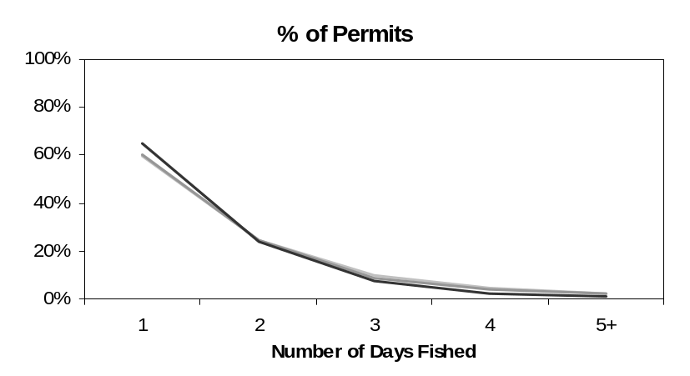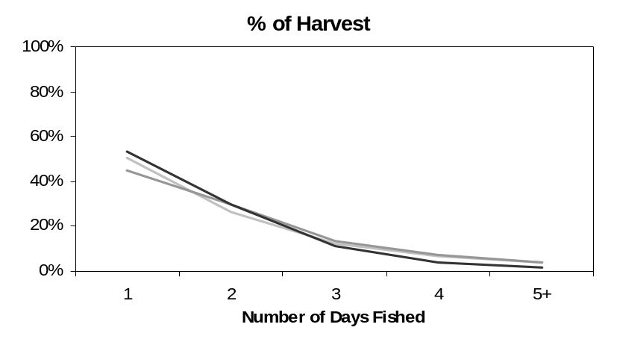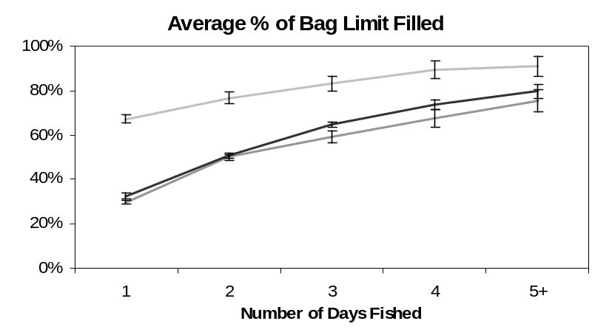

Kasilof River Gillnet
Kasilof River Dip Net
Kenai River Dip Net

ª Data presented are for permit holders that only participated in one fishery (92% of permit holders who fished).
^{b.} Error bars represent 95% confidence intervals.

Figure 11.–Percent of permits, percent of total harvest and average percent of bag limit filled by fishery and number of days fished from 2004-2006.
There are fishery related explanations for the increased harvest and effort levels. Interest in the UCIPU fisheries increased during this study as indicated by the numbers of permits issued (Table 1; Reimer and Sigurdsson 2004), and most of the effort occurred in the Kenai River dip net fishery (Table 3, Figure 9). Also, the percentages of permit holders who were issued permits but did not fish were lower than previously reported (Table 2; Reimer and Sigurdsson 2004).
2006 was an atypical year for the Kenai River dip net fishery. Compared with previous years, effort and sockeye salmon harvest estimates in 2006 were relatively low (Appendix C1 and C2). The sockeye return was late in 2006, resulting in in-season management that closed the fishery on July 21st. The fishery was re-opened on July 31st, the last day of the legal fishing season. The season then closed but was opened again from July 3rd – 8th. Only about 20% of the sockeye harvested that year were taken when the fishery re-opened. Permit holders who would have ordinarily fished the Kenai dip net fishery during the closure either chose not to participate (Table 2) or chose to participate in the Kasilof River dip net fishery (Table 3; Figure 9).
It is not surprising then that the greatest effort and sockeye salmon harvest in the Kasilof River dip net fishery during the last ten years occurred in 2006 (Appendices C1 and C2). However, harvests of other salmon species in the Kasilof River dip net fishery during this study were not substantially different from previous years (Appendices C3-C6). Effort, sockeye salmon harvest, and coho salmon harvest in the Kasilof gillnet fishery were also higher during this study (Appendices C1- C3). Chinook harvests in the Kasilof gillnet fishery were variable and did not differ from pervious years (Appendix C4). Throughout the last ten years, chum and pink salmon harvests in this fishery were always very low (Appendices C5 and C6). The Kasilof River gillnet fishery is the least popular of all UCIPU fisheries, but participants in this fishery are the most successful in filling their bag limits (Figure 8). This is consistent with the trend observed by Reimer and Sigurdsson from 1996 - 2003.
Analysis of UCIPU fisheries indicates that the bag limit exceeds most permit holders’ actual harvest (Figure 7). In addition, the current bag limit increases at a faster rate than larger households increase their harvest (Table 7, Figure 10). Most permit holders did not fill their seasonal bag limit although differences in the percentage of the bag limit filled varied with respect to the year of the study and the amount of effort spent fishing (Table 7, Figure 11). Residency trends observed during this study were similar to those reported by Reimer and Sigurdsson. Most permits were issued to residents of Anchorage followed by residents of the Kenai Peninsula and the Matanuska-Susitna Valley, and relatively few permits were issued to Alaskans who did not reside in Southcentral Alaska (Table 6, Figure 6).
In the past, public perception with regard to the UCIPU fisheries is that regulatory violations are common (Barrett 2001a, 2001b, Reimer and Sigurdsson 2004). Reimer and Sigurdsson discussed that regulatory violations were often recorded on harvest cards between 1996 and 2003. Regulatory violations were also observed during this study. For example, Chinook salmon harvests were reported from the Kasilof River dip net fishery where regulations do not allow retention of Chinook (Table 3, Appendix C4). Also, a small number of permit holders reported harvesting over 100% of their seasonal bag limit (Figure 7). In addition, a few permits holders each year gave out-of-state addresses on the vendor copy of their permit (Table 6).
While the aforementioned regulatory violations display a lack of understanding of personal use fishing regulations by some permit holders, accurate reporting is essential to the accuracy of the estimates, and regulatory violations of this nature are enforced during the fisheries by Alaska Bureau of Wildlife Enforcement (ABWE) officers. More significant problems would be if large numbers of fishermen were not obtaining permits or failing to return obtained permits. Local ABWE officers indicate that they rarely encounter personal use fishermen who do not have a permit. However, from 1996 – 2003, Reimer and Sigurdsson reported a steady increase in the numbers of permit holders who failed to return their Upper Cook Inlet personal use fishing permits. Failure to return this permit is a regulatory violation that could interfere with the Division’s ability to meet project objectives. Fortunately, during this study, compliance in returning permits increased (Table 1). However, concerns that permit return rates may again decrease has prompted the Division to begin enforcement efforts against permit holders who fail to return their permits. ABWE officers will be issuing citations to those permit holders that received permits in 2005 and 2006 but failed to return their permit either year. The goal of this enforcement action is to make the public more aware of the regulations, the importance of following them, and, ultimately, increase compliance with the UCIPU fishery regulations.

ACKNOWLEDGEMENTS

Thanks are due to all individuals involved with the success of this project. ADF&G staff who have worked as principal investigators include Kristine Dunker, Robert Lafferty and Kirk Brogdon. Pat Hansen has served as the project biometrician. In addition, ADF&G staff were charged with the sizeable task of entering the data from approximately 20,000 permits per year. Margie Nussbaum, Diane Novinska, and Sabrina Pulu have helped in this regard. In addition to ADF&G staff, there are over 60 vendors who are responsible for the distribution of Upper Cook Inlet personal use permits. Their help is invaluable, and they deserve many thanks.

references Cited

Barrett, J. 2001. Dipnetting spawns fishing frenzy, personal-use fishery brings no shortage of concerns. Peninsula Clarion. July 13, 2001. Kenai.
Barrett, J. 2001. Scofflaws reportedly abundant in fishery. Peninsula Clarion. July 13, 2001. Kenai.
Brannian, L., and J. Fox. 1996. Upper Cook Inlet subsistence and personal use fisheries, report to the Alaska Board of Fisheries, 1996. Alaska Department of Fish and Game, Division of Commercial Fisheries Management and Development. Regional Information Report N0. 2A96-03. Anchorage.
Goodman, L. A. 1960. On the exact variance of products. Journal of the American Statistical Association 55:708-713.
Jennings, G. B., K. Sundet, A. E. Bingham, and D. Sigurdsson. 2006. Participation, catch, and harvest in Alaska sport fisheries during 2003. Alaska Department of Fish and Game, Fishery Data Series, Anchorage.
Reimer, A.M. and D. Sigurdsson. Upper Cook Inlet Personal Use Salmon Fisheries, 1996-2003. Alaska Department of Fish and Game, Fishery Data Series, Anchorage.
Tobias, T., and M. Willette. In prep. An estimate of total run of sockeye salmon to Upper Cook Inlet, Alaska 1976-2006. Alaska Department of Fish and Game, Commercial Fisheries Division, Anchorage.

APPENDIX A. Examples OF upper cook inlet personal use permits

Appendix A1.-Example of a 2006 Upper Cook Inlet personal use salmon permit.
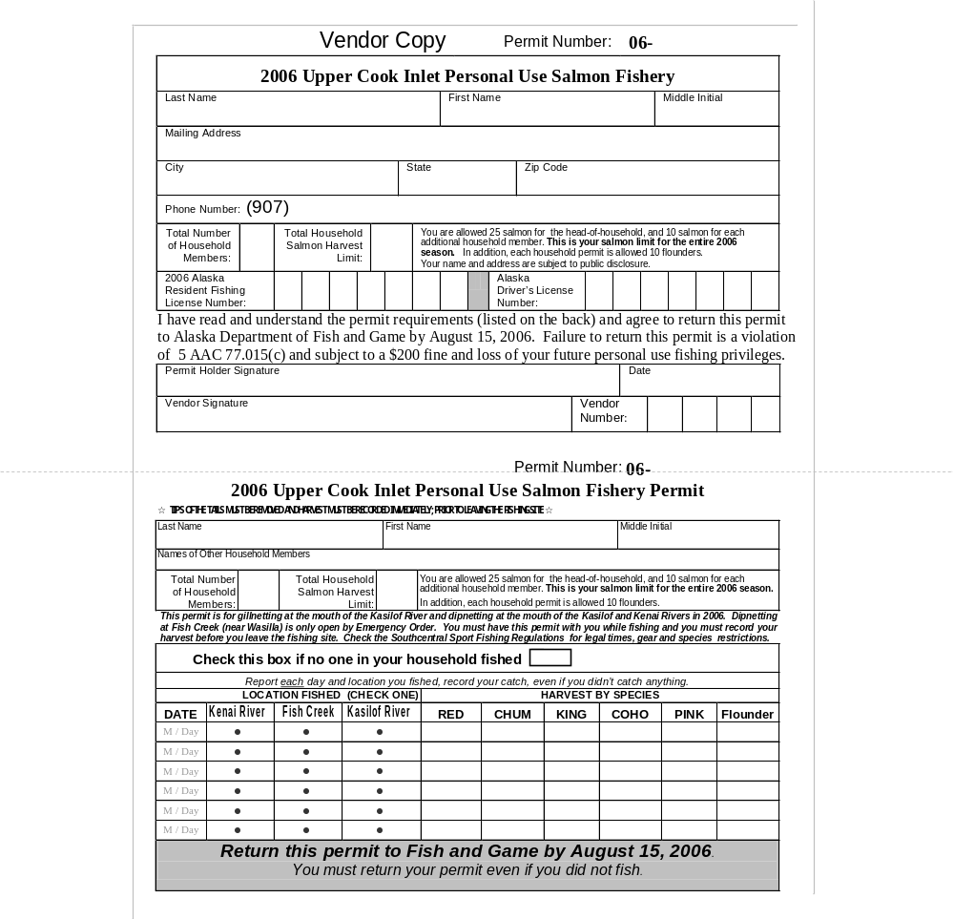

Appendix A1.-Page 2 of 2.
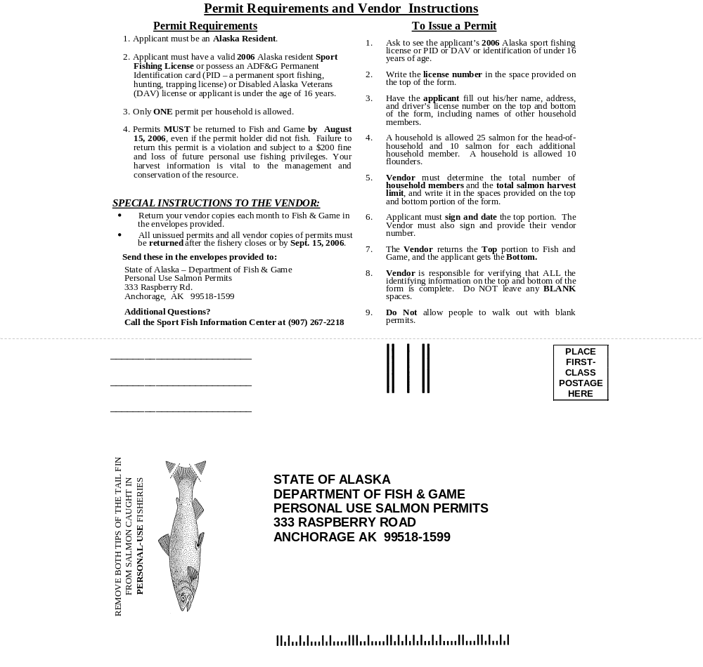

Appendix A2.-Example of a 2005 Upper Cook Inlet personal use salmon permit.
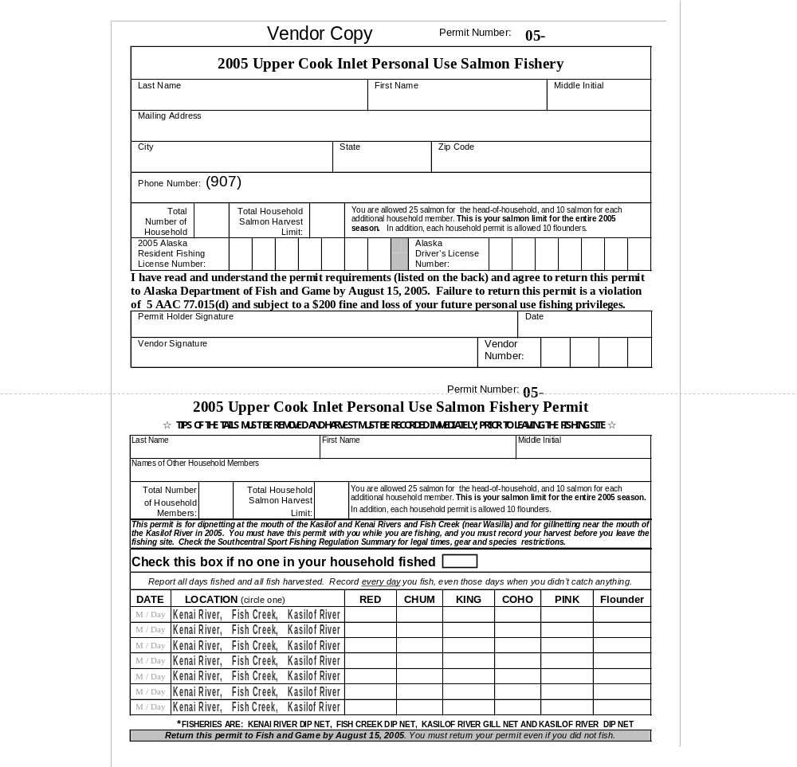
APPENDIX B. SOCKEYE HARVEST BY DATE During the Upper Cook Inlet personal use fisheries, 2004-2006

Appendix B1.–Sockeye harvest by date during the Kasilof River gillnet fishery, 2004-2006.

 |  | 2004 |  |  |  | 2005 |  |  |  | 2006
Date | Total | Meanª | SE |  | Total | Meanª | SE |  | Total | Meanª | SE
15-Jun | 1,474 | 12.6 | 1.0 |  | 3,024 | 20.6 | 1.2 |  | 2,551 | 14.3 | 0.7
16-Jun | 1,329 | 14.0 | 1.1 |  | 2,612 | 18.4 | 1.1 |  | 3,033 | 15.6 | 0.9
17-Jun | 1,953 | 16.0 | 1.1 |  | 3,549 | 20.9 | 1.3 |  | 3,428 | 15.8 | 0.8
18-Jun | 2,266 | 15.5 | 1.0 |  | 3,566 | 21.1 | 1.2 |  | 2,376 | 14.1 | 0.8
19-Jun | 2,912 | 18.5 | 1.0 |  | 2,832 | 20.7 | 1.3 |  | 2,056 | 15.3 | 1.1
20-Jun | 3,531 | 22.6 | 1.3 |  | 2,589 | 17.9 | 1.1 |  | 2,519 | 16.5 | 1
21-Jun | 3,185 | 26.5 | 1.4 |  | 1,467 | 10.8 | 0.8 |  | 2,845 | 19.1 | 1.1
22-Jun | 3,229 | 30.2 | 2.0 |  | 907 | 10 | 0.8 |  | 2,732 | 20.1 | 1.1
23-Jun | 1,482 | 27.0 | 2.4 |  | 660 | 8 | 0.9 |  | 1,935 | 15.6 | 1.1
24-Jun | 1,019 | 22.6 | 2.2 |  | 2,147 | 20.6 | 1.5 |  | 3,410 | 22.4 | 1.2
ª Mean is mean harvest per permit.
^{b} Data presented are for "known" permits during legal harvest dates only.
^{c} EO 2-S-1-05 extended gillnetting from June 24 to June 25 in 2005; data were not distinguished
between "gill net" and "dip net" in the database and are, therefore, not presented here.

Appendix B2.–Sockeye harvest by date during the Kasilof River dip net fishery, 2004-2006.
 |  | 2004 |  |  |  | 2005 |  |  |  |  | 2006
Date | Total | Meanª | SE |  | Total | Meanª | SE |  |  | Total | Meanª | SE
25-Jun | 673 | 8.7 | 1.2 |  | 1,973 | 11.7 | 1.0 |  |  | 788 | 9.0 | 0.8
26-Jun | 335 | 5.6 | 1.0 |  | 624 | 6.7 | 0.7 |  |  | 555 | 13.2 | 2.3
27-Jun | 728 | 9.5 | 0.8 |  | 234 | 6.9 | 1.1 |  |  | 613 | 9.7 | 1.0
28-Jun | 324 | 9.8 | 1.5 |  | 617 | 10.5 | 1.1 |  |  | 259 | 7.8 | 1.1
29-Jun | 793 | 13.2 | 2.0 |  | 391 | 9.1 | 1.8 |  |  | 343 | 8.2 | 1.2
30-Jun | 275 | 6.7 | 1.7 |  | 326 | 7.1 | 0.9 |  |  | 137 | 4.2 | 0.9
1-Jul | 635 | 9.8 | 1.5 |  | 1,534 | 11.8 | 0.8 |  |  | 705 | 6.8 | 0.9
2-Jul | 731 | 7.3 | 0.6 |  | 887 | 6.6 | 0.5 |  |  | 811 | 7.0 | 0.8
3-Jul | 912 | 7.0 | 0.6 |  | 991 | 7.6 | 0.7 |  |  | 284 | 4.4 | 0.6
4-Jul | 664 | 7.2 | 1.0 |  | 854 | 9.6 | 1.0 |  |  | 951 | 10.6 | 1.2
5-Jul | 351 | 6.8 | 1.2 |  | 711 | 9.4 | 1.1 |  |  | 565 | 8.6 | 1.1
6-Jul | 757 | 11.3 | 1.3 |  | 578 | 9.5 | 1.4 |  |  | 1,021 | 11.3 | 1.4
7-Jul | 1,005 | 12.6 | 1.1 |  | 333 | 5.5 | 0.8 |  |  | 644 | 7.4 | 0.8
8-Jul | 468 | 10.6 | 1.9 |  | 493 | 5.7 | 0.8 |  |  | 844 | 6.5 | 0.5
9-Jul | 537 | 5.5 | 0.6 |  | 699 | 5 | 0.5 |  |  | 523 | 5.9 | 0.8
10-Jul | 498 | 5.2 | 0.8 |  | 614 | 7.6 | 0.9 |  |  | 728 | 8.2 | 0.8
11-Jul | 685 | 6.1 | 0.6 |  | 845 | 11.9 | 1.3 |  |  | 369 | 4.2 | 0.5
12-Jul | 749 | 10.1 | 1.1 |  | 969 | 11.7 | 1.2 |  |  | 599 | 4.9 | 0.7
13-Jul | 2,838 | 23.5 | 1.4 |  | 787 | 9.5 | 0.9 |  |  | 643 | 5.4 | 0.6
14-Jul | 3,574 | 21.1 | 1.2 |  | 612 | 6.9 | 0.9 |  |  | 2,821 | 10.0 | 0.5
15-Jul | 1,788 | 13.9 | 1.0 |  | 1,069 | 7.9 | 0.7 |  |  | 6,967 | 14.2 | 0.5
16-Jul | 2,333 | 11.8 | 0.8 |  | 2,360 | 11.5 | 0.7 |  |  | 1,564 | 8.5 | 0.6
17-Jul | 2,204 | 8.5 | 0.5 |  | 1,228 | 9.7 | 0.8 |  |  | 1,095 | 8.2 | 0.8
18-Jul | 1,444 | 8.8 | 0.8 |  | 796 | 11.2 | 1.0 |  |  | 1,061 | 7.9 | 0.7
19-Jul | 680 | 7.8 | 1.0 |  | 908 | 10.2 | 0.9 |  |  | 750 | 6.9 | 0.8
20-Jul | 2,225 | 14.4 | 1.2 |  | 814 | 8.8 | 0.8 |  |  | 1,381 | 10.4 | 1.0
21-Jul | 2,041 | 15.0 | 1.2 |  | 803 | 9.8 | 1.0 |  |  | 1,218 | 7.1 | 0.7
22-Jul | 790 | 10.7 | 1.2 |  | 1,042 | 11.7 | 1.1 |  |  | 971 | 4.1 | 0.3
23-Jul | 929 | 10.7 | 1.1 |  | 1,589 | 12 | 1.0 |  |  | 622 | 4.7 | 0.6
24-Jul | 1,160 | 9.4 | 0.9 |  | 859 | 10.7 | 1.0 |  |  | 1,435 | 11.1 | 0.9
25-Jul | 728 | 9.2 | 1.0 |  | 582 | 11.2 | 1.2 |  |  | 1,092 | 9.0 | 0.8
26-Jul | 314 | 11.2 | 1.7 |  | 375 | 11.0 | 1.8 |  |  | 758 | 9.4 | 1.1
27-Jul | 422 | 13.6 | 2.7 |  | 255 | 9.1 | 1.7 |  |  | 807 | 9.1 | 1.3
28-Jul | 426 | 14.2 | 1.9 |  | 329 | 10.6 | 1.7 |  |  | 3,809 | 19.1 | 1.0
29-Jul | 358 | 9.0 | 1.4 |  | 425 | 10.0 | 1.1 |  |  | 1,882 | 11.2 | 1.0
30-Jul | 569 | 10.3 | 1.4 |  | 673 | 11.0 | 1.5 |  |  | 3,624 | 16.9 | 0.8
31-Jul | 439 | 7.7 | 1.1 |  | 324 | 9.0 | 1.6 |  |  | 978 | 13.6 | 1.6
1-Aug | 423 | 8.8 | 1.2 |  | 250 | 7.6 | 1.2 |  |  | 1,205 | 19.4 | 2.4
2-Aug | 323 | 10.1 | 2.1 |  | 355 | 11.1 | 1.8 |  |  | 689 | 11.7 | 1.3
3-Aug | 647 | 16.6 | 2.2 |  | 273 | 9.8 | 1.6 |  |  | 827 | 13.3 | 1.7
4-Aug | 364 | 13.0 | 2.1 |  | 141 | 5.0 | 1.0 |  |  | 595 | 9.6 | 1.0
5-Aug | 226 | 7.5 | 1.1 |  | 609 | 10.9 | 1.1 |  |  | 535 | 7.2 | 0.8
6-Aug | 325 | 7.1 | 0.9 |  | 403 | 6.7 | 1.2 |  |  | 460 | 8.5 | 1.0
7-Aug | 469 | 8.2 | 1.4 |  | 137 | 4.3 | 0.7 |  |  | 231 | 8.9 | 2.2
ª Mean harvest per permit.
^{b} Data presented are for "known" permits during legal harvest dates only.
Appendix B3.–Sockeye harvest by date during the Kenai River dip net fishery, 2004-2006.
 |  | 2004 |  |  |  | 2005 |  |  |  | 2006
Date | Total | Mean | SE |  | Total | Mean | SE |  | Total | Mean | SE
10-Jul | 1,416 | 4.6 | 0.4 |  | 3,966 | 11.0 | 0.6 |  | 1,066 | 5.4 | 0.5
11-Jul | 950 | 4.5 | 0.6 |  | 3,754 | 13.7 | 0.7 |  | 848 | 4.4 | 0.4
12-Jul | 1,339 | 7.7 | 0.8 |  | 5,905 | 14.8 | 0.6 |  | 946 | 4.2 | 0.4
13-Jul | 10,005 | 21.4 | 0.7 |  | 5,363 | 10.1 | 0.4 |  | 820 | 3.7 | 0.3
14-Jul | 20,934 | 20.7 | 0.4 |  | 4,265 | 7.7 | 0.4 |  | 2,783 | 6.8 | 0.4
15-Jul | 18,854 | 18.6 | 0.4 |  | 16,085 | 14.9 | 0.4 |  | 8,930 | 11.0 | 0.3
16-Jul | 19,397 | 14.6 | 0.3 |  | 24,157 | 17.2 | 0.4 |  | 10,365 | 13.0 | 0.4
17-Jul | 15,715 | 10.4 | 0.3 |  | 14,353 | 14.7 | 0.4 |  | 5,390 | 8.1 | 0.3
18-Jul | 7,135 | 7.9 | 0.3 |  | 16,033 | 19.0 | 0.5 |  | 4,798 | 5.8 | 0.2
19-Jul | 4,352 | 7.6 | 0.4 |  | 8,668 | 12.3 | 0.4 |  | 6,469 | 7.2 | 0.3
20-Jul | 13,008 | 12.6 | 0.4 |  | 10,908 | 11.4 | 0.3 |  | 13,512 | 12.3 | 0.3
21-Jul | 31,776 | 22.5 | 0.4 |  | 8,153 | 11.0 | 0.4 |  | 30,607 | 18.5 | 0.3
22-Jul | 6,321 | 11.4 | 0.5 |  | 19,858 | 18.0 | 0.4
23-Jul | 10,803 | 13.4 | 0.4 |  | 20,324 | 15.9 | 0.4
24-Jul | 13,525 | 14.0 | 0.4 |  | 9,077 | 12.75 | 0.4
25-Jul | 9,174 | 15.2 | 0.5 |  | 5,093 | 12.6 | 0.5
26-Jul | 4,664 | 15.9 | 0.7 |  | 3,427 | 9.7 | 0.5
27-Jul | 5,569 | 16.6 | 0.7 |  | 2,086 | 7.5 | 0.5
28-Jul | 6,141 | 15.8 | 0.7 |  | 3,143 | 9.9 | 0.6
29-Jul | 4,677 | 14.9 | 0.7 |  | 7,160 | 15.9 | 0.6
30-Jul | 4,151 | 11.3 | 0.5 |  | 9,694 | 15.2 | 0.5
31-Jul | 4,271 | 10.1 | 0.5 |  | 2,740 | 10.0 | 0.6 |  | 6,030 | 10.1 | 0.4
1-Aug
2-Aug
3-Aug |  |  |  |  |  |  |  |  | 102 | 3.8 | 1
4-Aug |  |  |  |  |  |  |  |  | 1,144 | 7.4 | 0.6
5-Aug |  |  |  |  |  |  |  |  | 3,844 | 7.4 | 0.3
6-Aug |  |  |  |  |  |  |  |  | 2,145 | 5.5 | 0.3
7-Aug |  |  |  |  |  |  |  |  | 1,707 | 6.9 | 0.5
8-Aug |  |  |  |  |  |  |  |  | 1,168 | 5.1 | 0.4
9-Aug |  |  |  |  |  |  |  |  | 1,316 | 6.6 | 0.5
10-Aug |  |  |  |  |  |  |  |  | 2,280 | 10.2 | 0.7
ª Mean is mean harvest per permit.
^{b} Data presented are for "known" permits during legal harvest dates.
^{c} EO 2-RS-1-16-06 closed dipnetting at the mouth of the Kenai River on July 21; EO 2-RS-1-34-06
re-opened dipnetting at the mouth of the Kenai River on July 31; EO 2-RS-1-37-06 re-opened
dipnetting at the mouth of the Kenai River from August 3 through August 10.

APPENDIX C. EFFORT AND HARVEST TRENDS During the Upper Cook Inlet personal use fisheries, 1996-2006

Appendix C1.–Trends in fishing effort during the UCIPU salmon fisheries, 1996-2006.

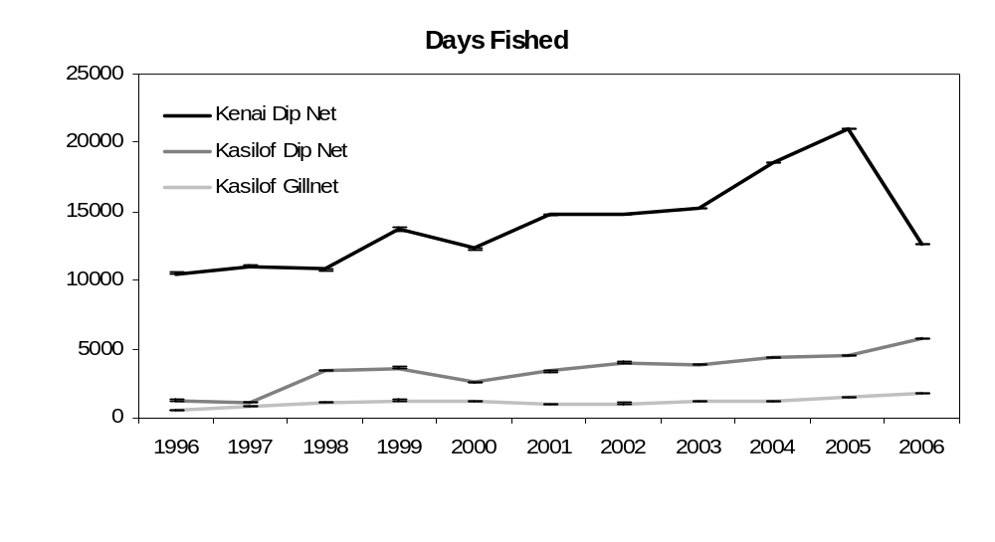
Estimated Days Fished
Appendix C2.–Trends in sockeye salmon harvest during the UCIPU salmon fisheries, 1996-2006.

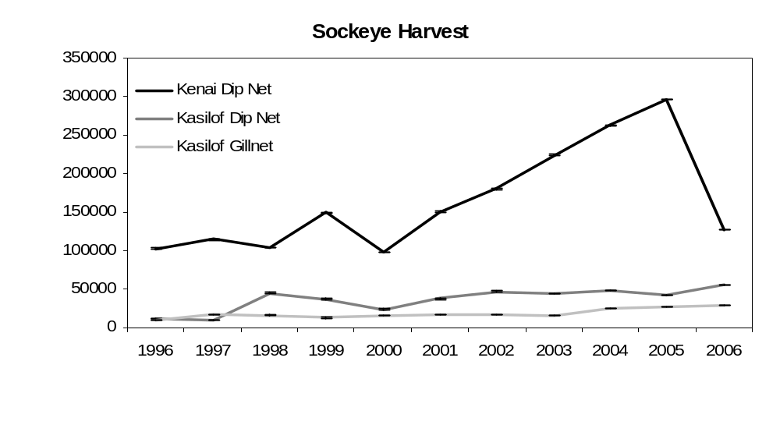
Estimated Harvest

Appendix C3.–Trends in coho salmon harvest during the UCIPU salmon fisheries, 1996-2006.

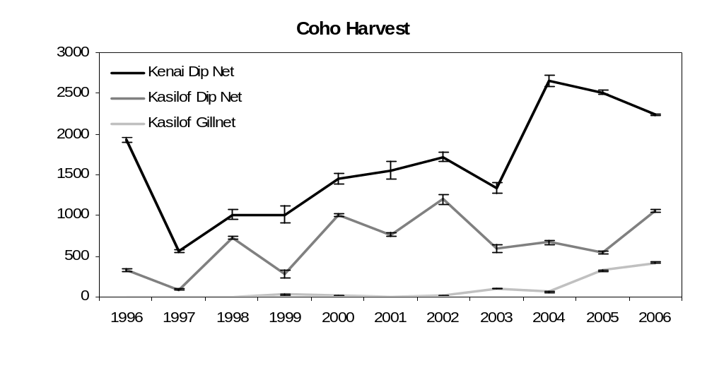
Estimated Harvest
Appendix C4.–Trends in Chinook salmon harvest during the UCIPU salmon fisheries, 1996-2006.

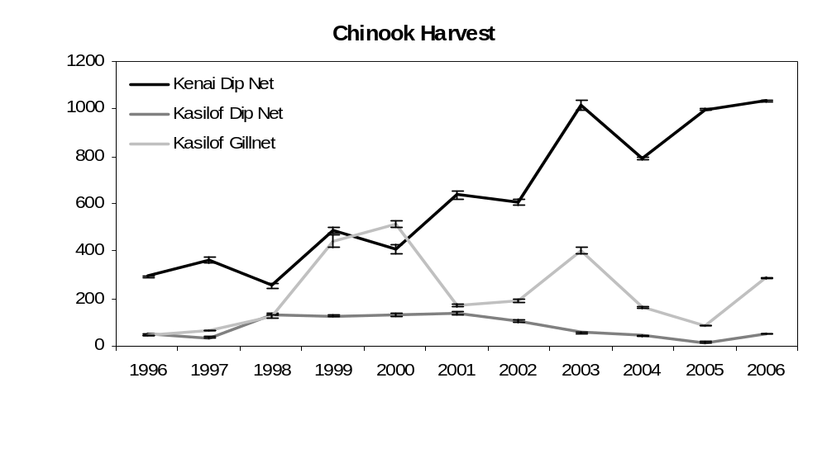
Estimated Harvest
Appendix C5.–Trends in chum salmon harvest during the UCIPU salmon fisheries, 1996-2006.

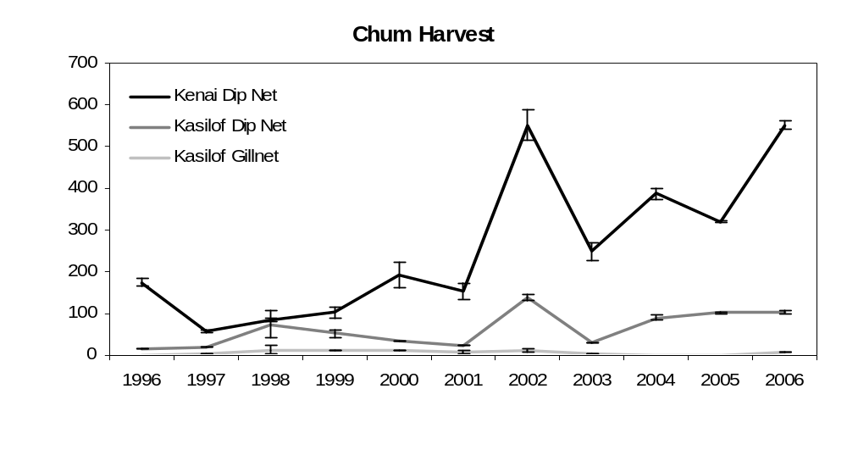
Estimated Harvest
Appendix C6.–Trends in pink salmon harvest during the UCIPU salmon fisheries, 1996-2006.

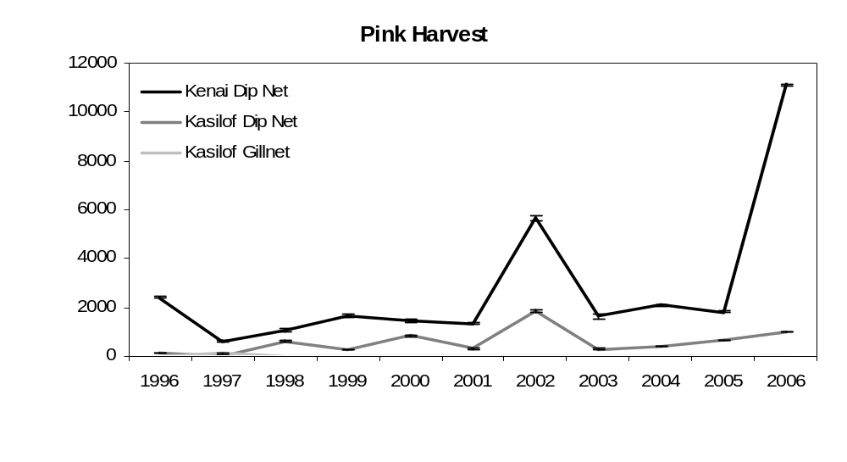
Estimated Harvest

